Assignment: UX extension

This assignment discusses and demonstrates the use of 4 UX patterns in 3 mobile apps which are.

**UX Patterns**

* Navigation tabs
* Search filter
* Home link
* Setting

**Mobile applications**

* Youtube
* Google Drive
* Notion

# Youtube

**Navigation bar**

In the youtube application, there is an example of a navigation bar that is placed at the bottom of the screen. It is labelled

1. Navigation bar, in the image. It is evident that this is an example of a navigation bar as this that the navigation bar uses 2 - 9 sections of information that navigate to other pages and the information is also labelled in short names. The entire navigation bar itself is wide as the screen. The pages it navigates to also are the more important and are the highest available sections to the application.

In addition, the selection option shown is

very general pages and not specific to a certain page, but instead general pages. Moreover, the navigation is simple and

general regarding what selection options there are and these selection options dont expand or open further as well. Therefore, for these reasons adhere to the UX pattern of the navigation bar.

**Search Filters**

Another, UX pattern that youtube demonstrates is the search filter. This is depicted to use the search bar to search a certain name of a video or the creator of the video itself, furthermore, the search bar itself filters what the user has typed to similar results to what string the user is typing. Also, there is another type of filter that appears when you are on any page. Where users can select specific categories to add to their search results. Henceforth, it can be demonstrated that the search filter in the youtube application is an example of a UX search filter pattern. As the filtering either in the search results when the user types in the search bar can decrease the possible results as the user types more of a cohesive string into the search bar. In addition to this users can select a category in which the specific videos in that category will be filtered and appear, as well as decrease the number of videos appearing to users, from a large amount to a small amount.

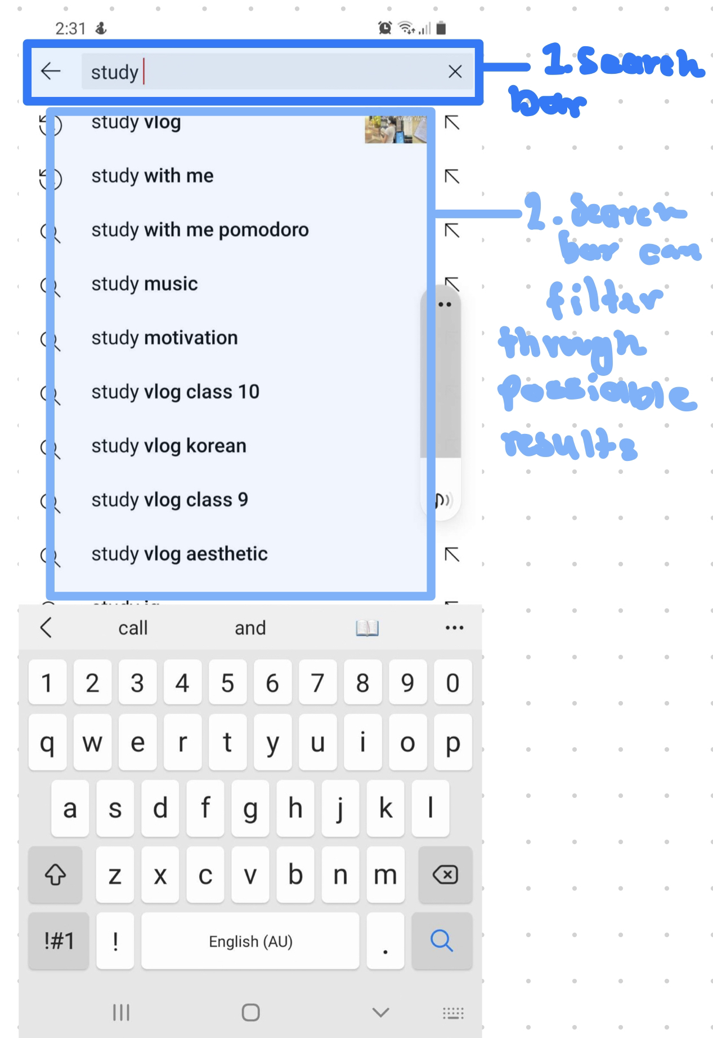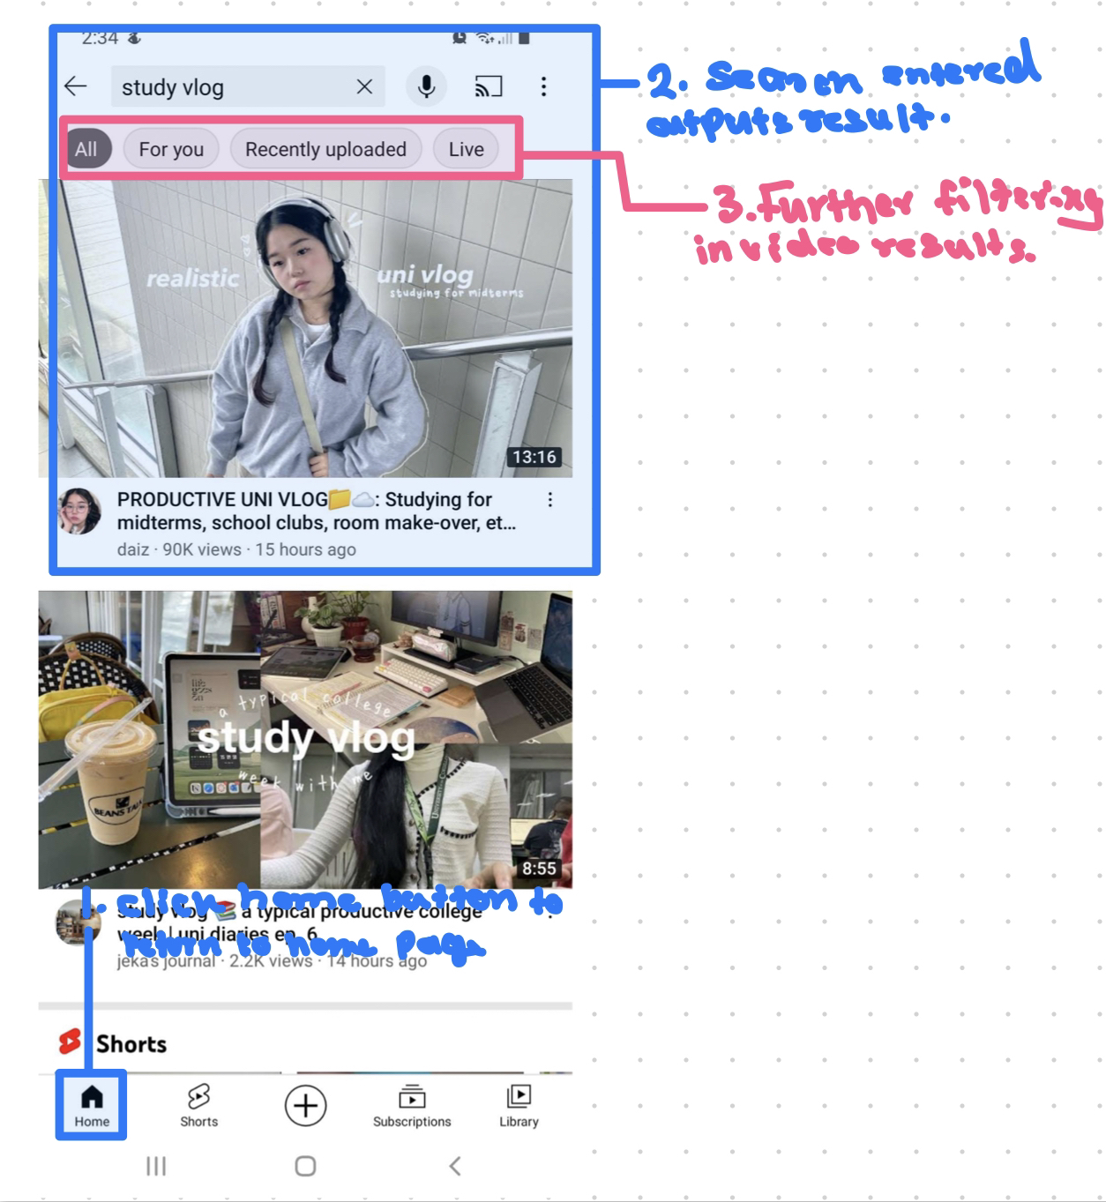

**Home button**

Another UX design pattern that appears in the youtube application is the home link which appears in the navigation bar. This home button link appears on every page due to it being attached to the navigation bar, and this adheres to the UX pattern design principles as the home button enables the user away to escape to the home page if they entered the app using a youtube video link and want to exit that video and go back the home page. Therefore adhering to the UX pattern design principle.

# 

# Google Drive

**Navigation bar**

Google doc app, has navigation that appears at the bottom of the screen and gives many options to popular pages which the user would more likely be using. The navigation bar is an example of the UX pattern as it has 2- 9 selection options, and the names of those selection options are relatively short. The navigation bar even though at the bottom of the page, takes up the entire width of the page the user is viewing. It is noted that this is similar to how youtube has placed its navigation bar. The pages the navigation bar has are pages that are in the highest order of page or main pages.

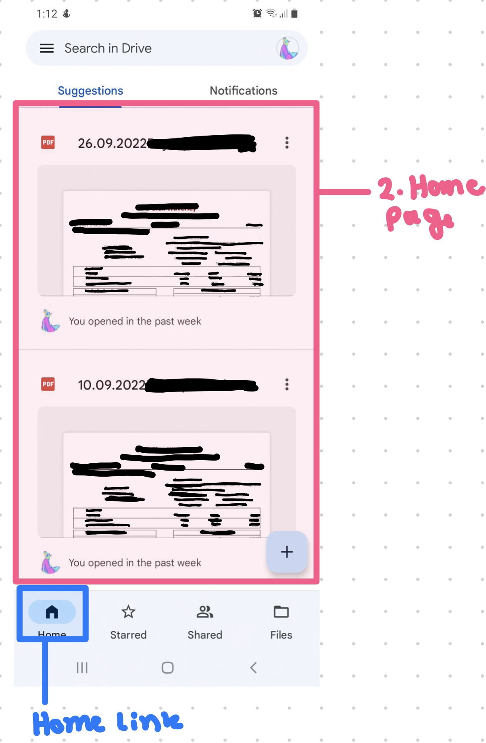

**Home link button**

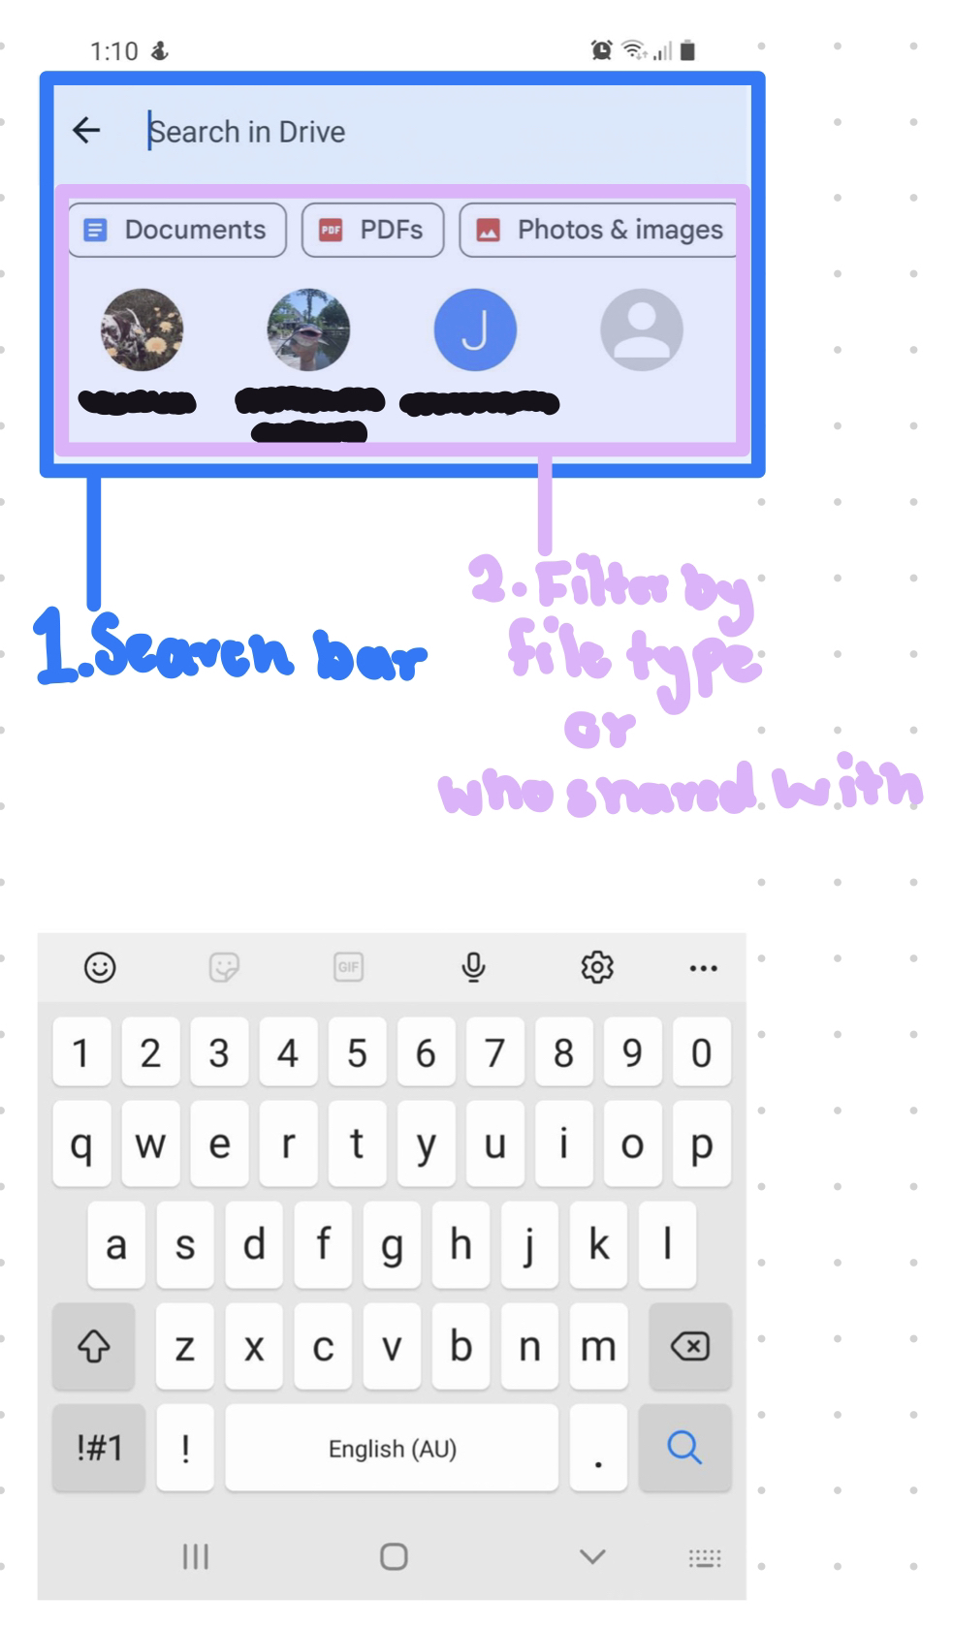

# Notion

